Ex.no:8 | MINI PROJECT – SOCIAL MEDIA ANALYTICS

Domain and Problem Statement

Domain: Social Media Analytics & Instagram Performance Analysis

Problem Statement:
Businesses and content creators generate large volumes of Instagram data but often lack clear insights into content performance, audience engagement, reach, and follower growth. This project addresses these challenges by transforming raw Instagram post data into structured business intelligence using Power BI and Tableau, enabling analysis of engagement trends, content performance, posting patterns, traffic sources, and overall Instagram performance to support data-driven content and marketing decisions.

Dataset Description

Dataset Name: Instagram Analytics Dataset Granularity: Each row represents a single Instagram post. Timeframe Covered: 2025

Key Entities & Attributes:

- Account & Content: account_id, account_type, media_type, content_category, caption_length, hashtags_count, has_call_to_action.
- Post Details: post_id, post_date, post_datetime, post_hour, day_of_week.
- Engagement Metrics: likes, comments, shares, saves, engagement_rate.
- Reach & Growth: reach, impressions, followers_gained, traffic_source.
- Performance: performance_bucket_label.

Data Source:
Primary Source: Instagram Analytics Dataset prepared for social media performance analysis.

Storage Infrastructure: Cleaned and pre-processed Instagram post records maintained in an Excel dataset and imported into Microsoft Power BI and Tableau for interactive dashboard development and analysis.

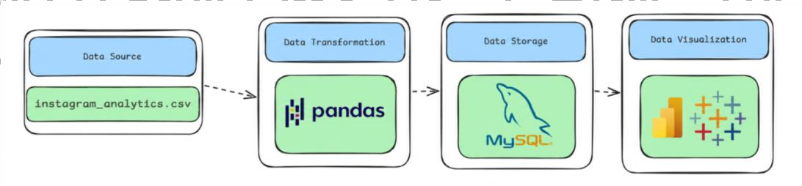
Architecture:
Program:
- Python – Data Cleaning & Transformation import pandas as pd df = pd.read_csv("instagram_analytics.cs v")
# Create a copy for processing instagram = df.copy() # Handle missing values instagram["account_type"] = instagram["account_type"].fillna("Unknown") instagram["media_type"] = instagram["media_type"].fillna("Unknown") instagram["content_category"] = instagram["content_category"].fillna("Unknown") instagram["traffic_source"] = instagram["traffic_source"].fillna("Unknown")
# Replace missing numerical values with 0 numeric_columns = [
"likes", "comments", "shares",
"saves",
"reach", "impressions", "followers_gained"
]

for column in numeric_columns: instagram[column] = instagram[column].fillna(0)

# Remove duplicate records
instagram.drop_duplicates(inplace=True)
# Convert date column instagram["post_date"] = pd.to_datetime(
instagram["post_date"], errors="coerce"
)
instagram.columns = ( instagram.columns
.str.lower()
.str.strip()
.str.replace(" ", "_")
)
# Display dataset information print("Original Shape:", df.shape) print("Cleaned Shape:", instagram.shape)

print("\nDataset Preview:") print(instagram.head())

print("\nDataset Information:") print(instagram.info())

SQL SERVER CONNECTIVITY

INSTALL SQL SERVER MANAGEMENT STUDIO 1) Create database named “dashboardDB”

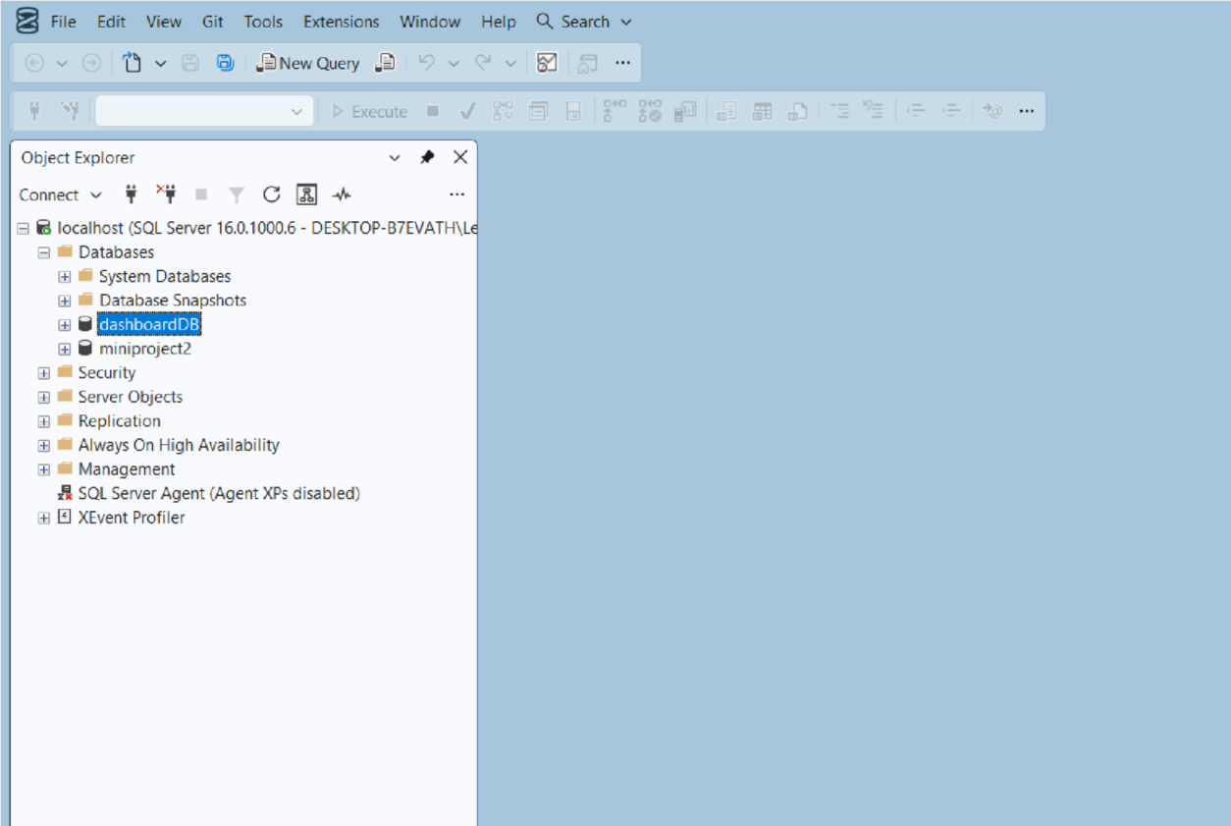

Import the csv file of the dataset
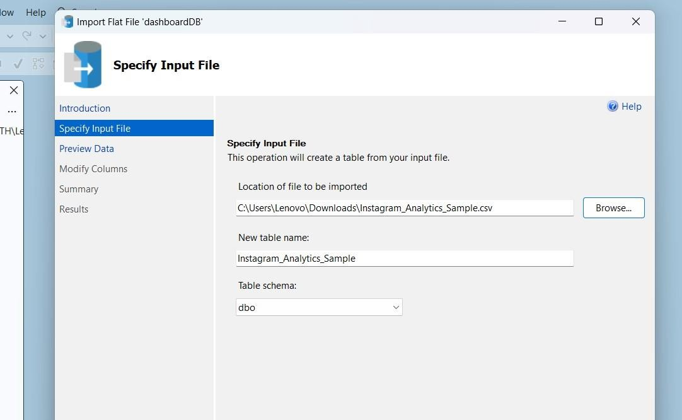

POWER BI

Now go to MICROSOFT POWER BI

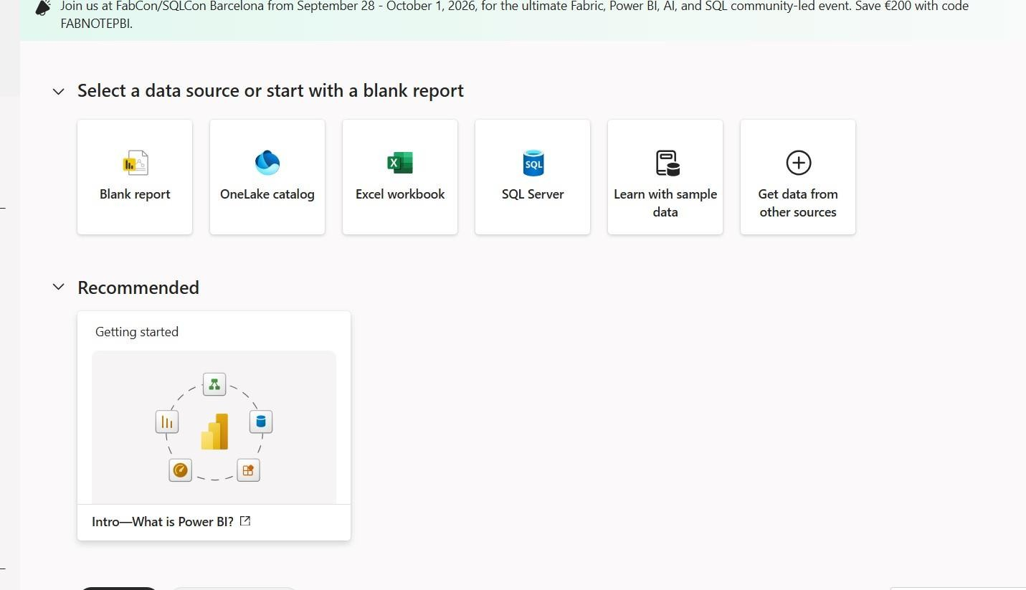

Click SQL SERVER
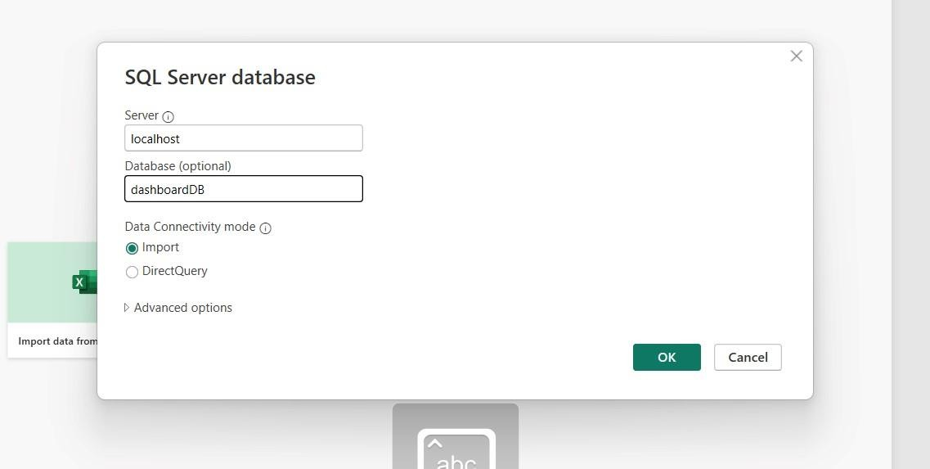

Click OK and click transform data

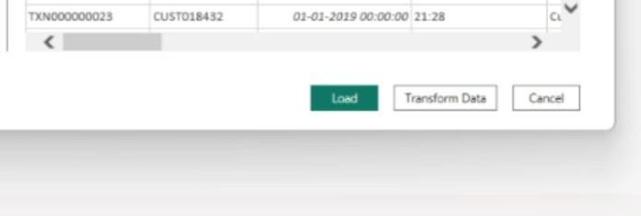

Create DAX measures TOTAL LIKES :

TOTAL POSTS:

TOTAL REACH
AVERAGE ENGAGEMENT RATE

Power BI Final Executive Dashboard & Drill-Through

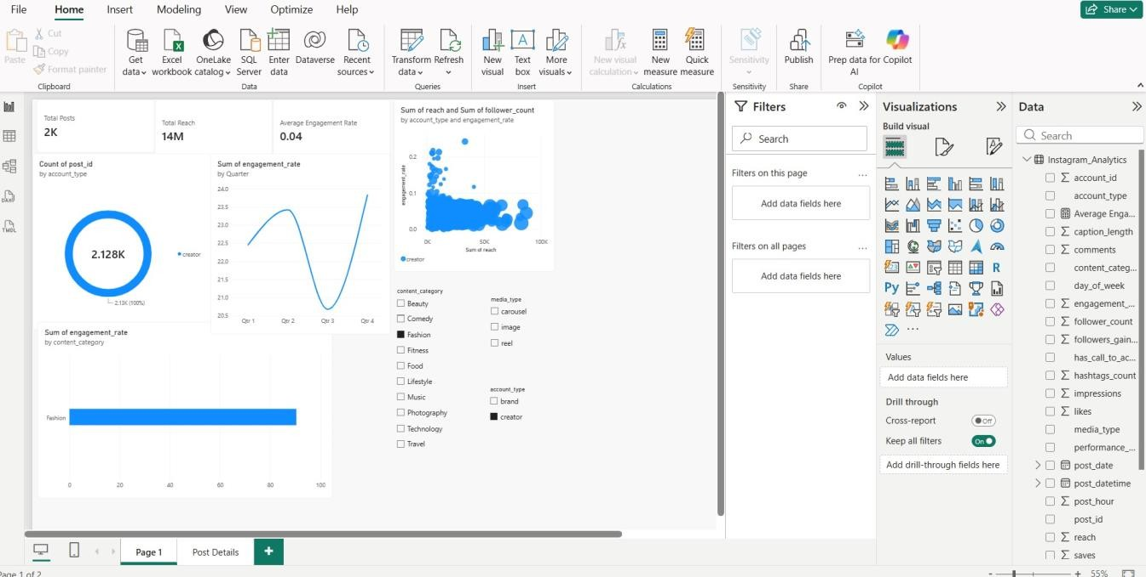

1. Executive Canvas:
Place Card Visuals across the top: Total Likes, Total Transaction Reach, Total Shares, Average Engagement Rate
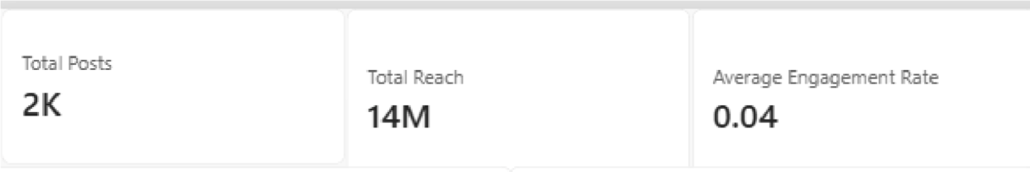
Add a Line Chart for sum of engagement rate .
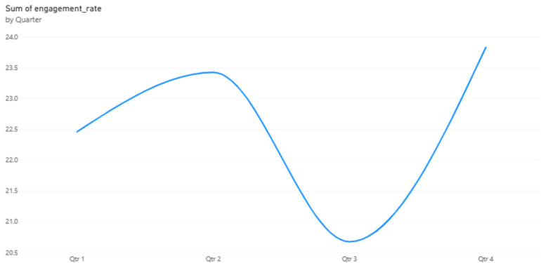
Enabled Drill Down

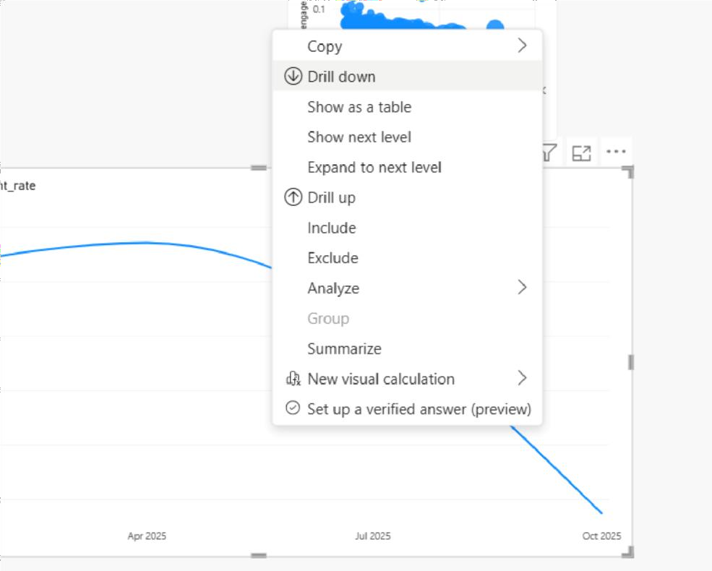

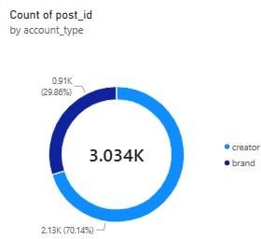
count by post id visualised by donut chart

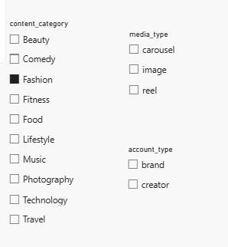
Create 3 slicers based on account type, content category and media type

Scatter plot for sum of reach and sum of follower count
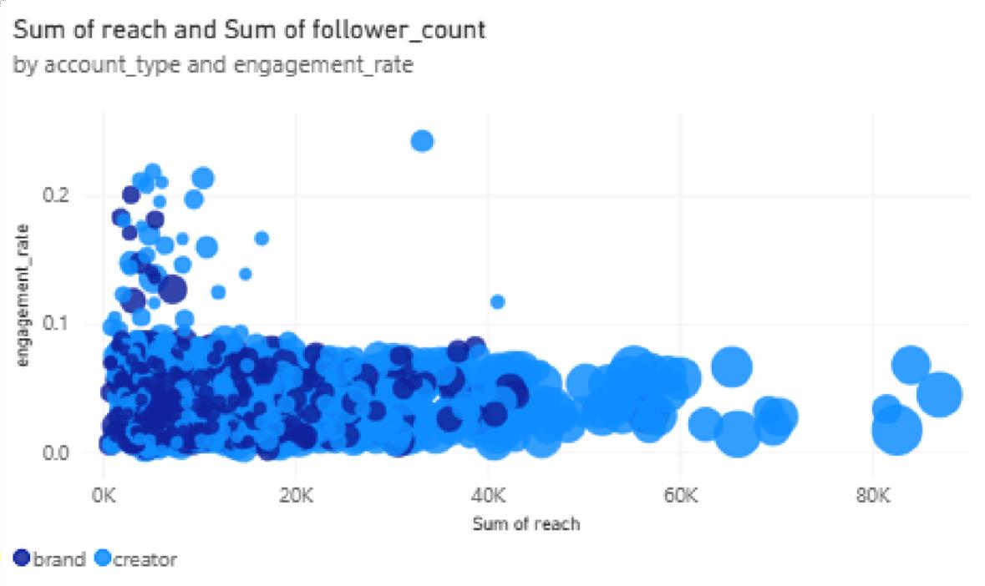

sum of engagement rate by content category
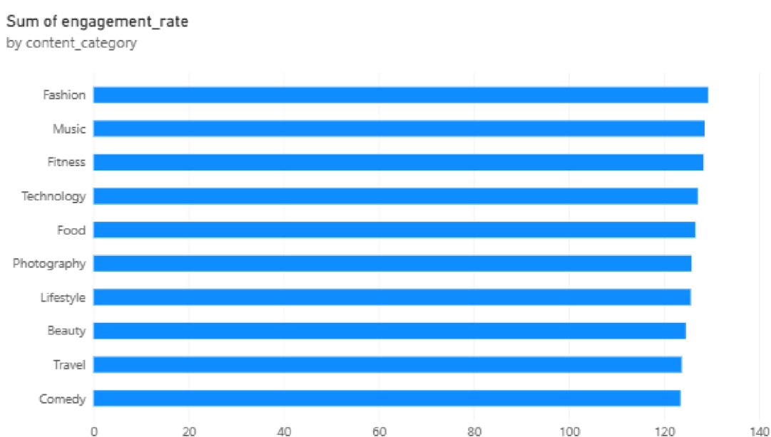

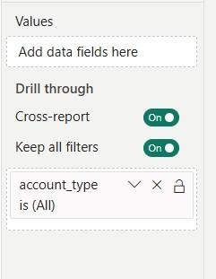
Enable drill-through

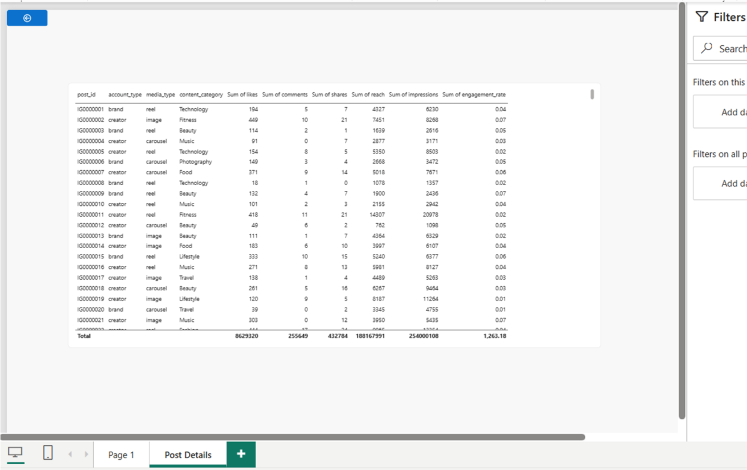

TABLEAU
Import the data from sql server
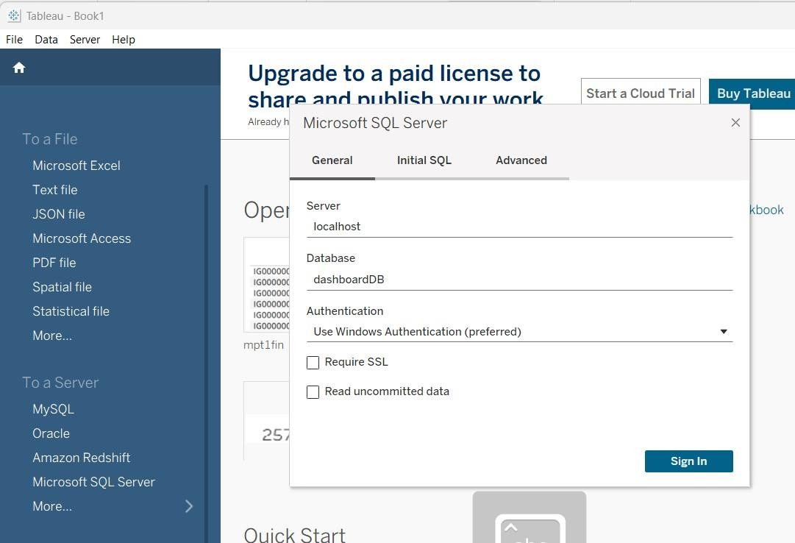

FINAL DASHBOARD :
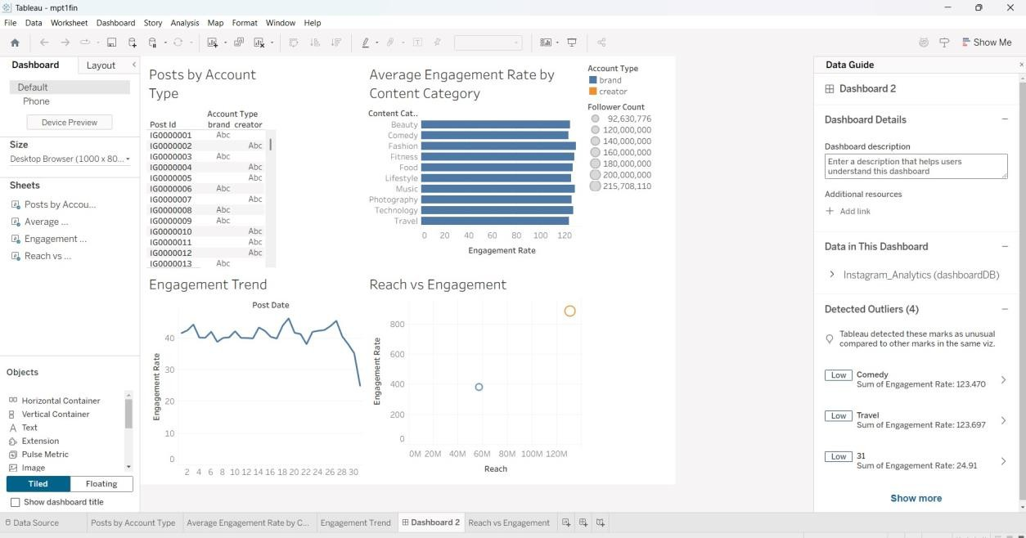
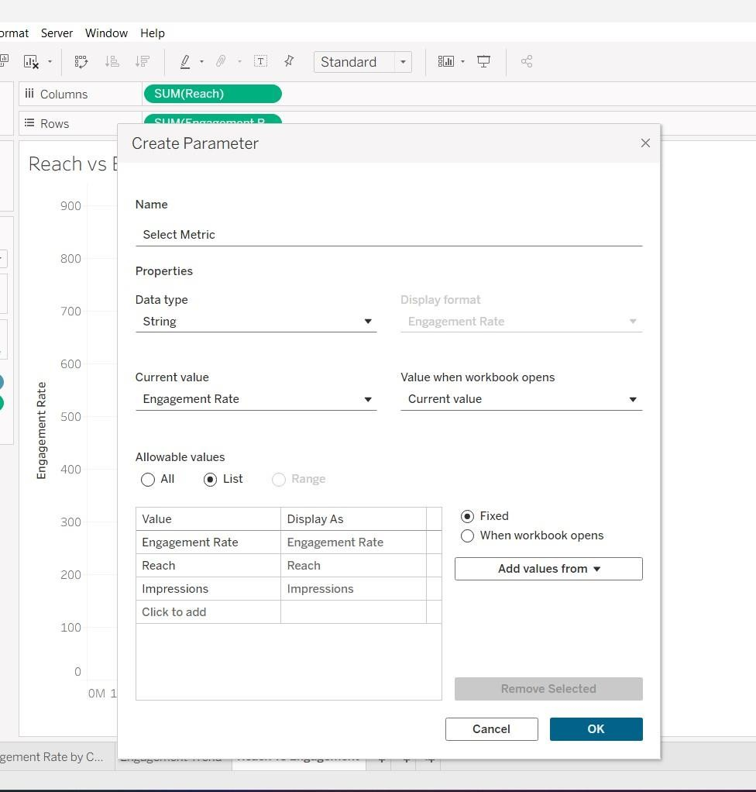
Build parameters

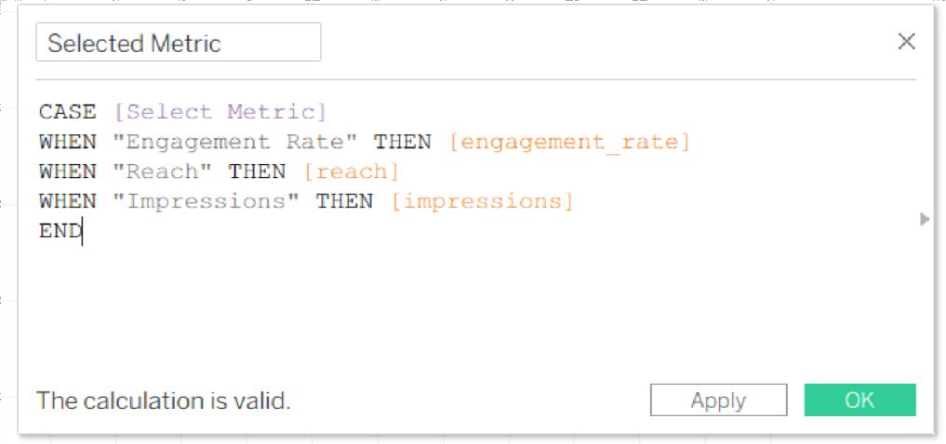

Create a table to display post by account type
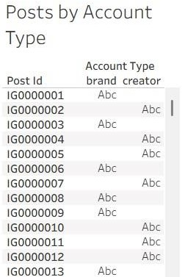

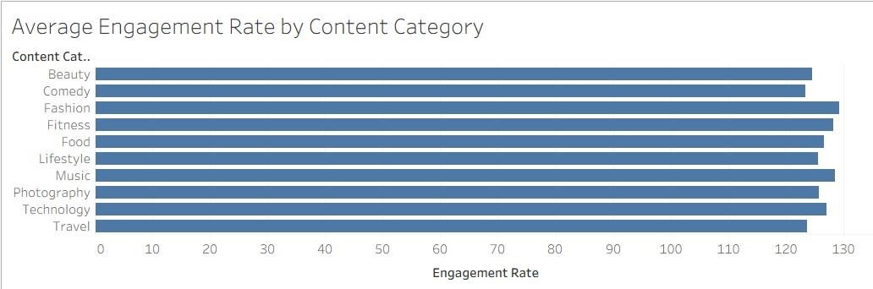
To display average engagement rate by content category

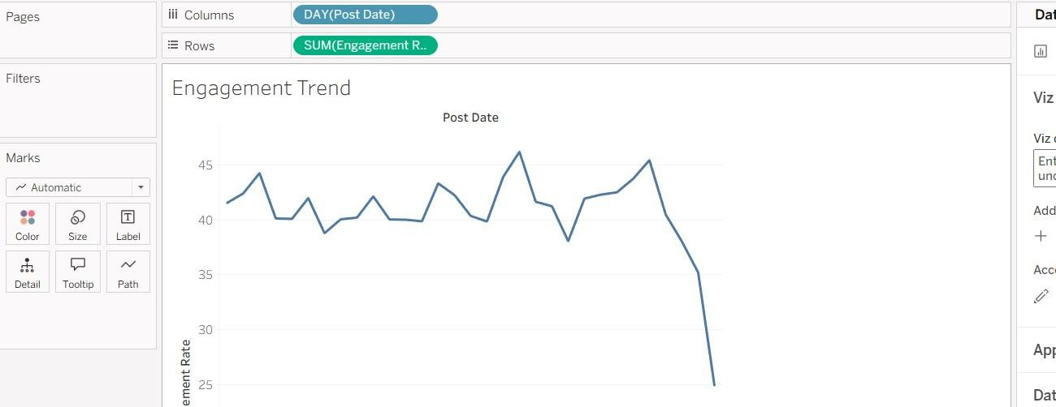
Line chart to visualise engagement trend with drill down

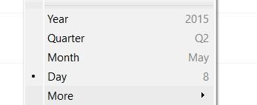

Reach VS Engagement Rate
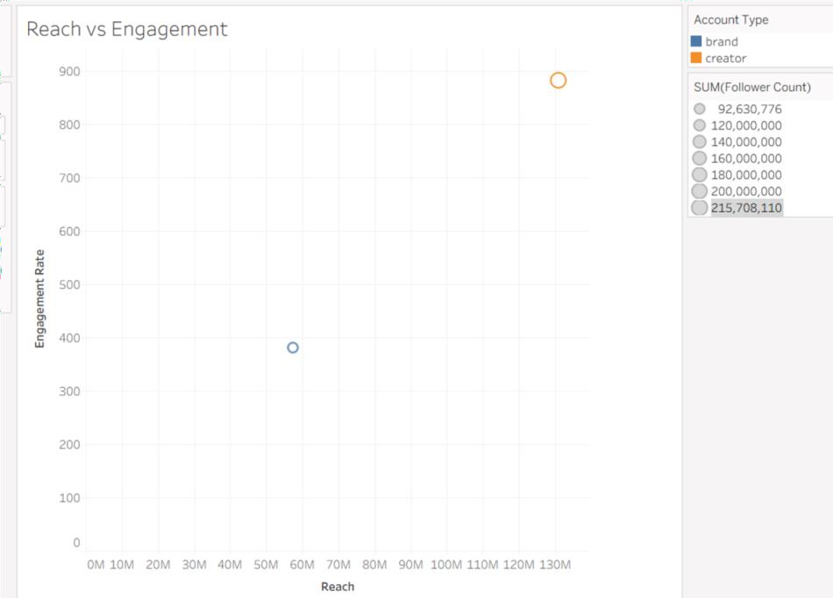

Observed Insights

- The dashboard contains approximately 30K Instagram posts with a total reach of 188M.
The average engagement rate is approximately 0.04.
This indicates a large volume of content and significant audience reach.
- Creator accounts contribute a larger share of posts than brand accounts.
Creators account for approximately 69.82% of the posts, while brands account for about
30.18%.
This shows that creator accounts dominate the dataset.
- Engagement varies across content categories, with Fashion showing the highest engagement.
Music and Fitness also show relatively high engagement compared with other categories. Comedy and Travel appear comparatively lower in the displayed chart.
- Engagement rate changes across the quarters, reaching its highest level in Q4. The trend increases from Q1 to Q2, decreases during Q3, and rises again in Q4.
This indicates noticeable variation in engagement performance throughout the year.

Ex.no:9 | MINI PROJECT – HEALTHCARE ANALYTICS

Domain and Problem Statement

Domain: Healthcare Data Analytics & Hospital Performance Analysis

Problem Statement:
Healthcare organizations generate large volumes of hospital-related data but often lack clear insights into hospital distribution, ratings, reviews, and regional patterns. This project addresses these challenges by transforming hospital data into structured business intelligence using Power BI and Tableau, enabling analysis of hospital distribution across states and cities, average ratings, review patterns, and overall hospital performance to support data-driven healthcare analysis.

Dataset Description

Dataset Name: Hospital Analytics Dataset Granularity: Each row represents a single hospital.

Key Entities & Attributes:

- Hospital & Location: id, City, State, District
- Geographical Information: Density, Latitude, Longitude
- Hospital Performance: Rating, Number of Reviews

Data Source:
Primary Source: Hospital Analytics Dataset prepared for healthcare and hospital performance analysis.

Storage Infrastructure:
Cleaned and pre-processed hospital records maintained in a CSV dataset and imported into Microsoft SQL Server, Power BI and Tableau for interactive dashboard development and analysis.

Architecture:

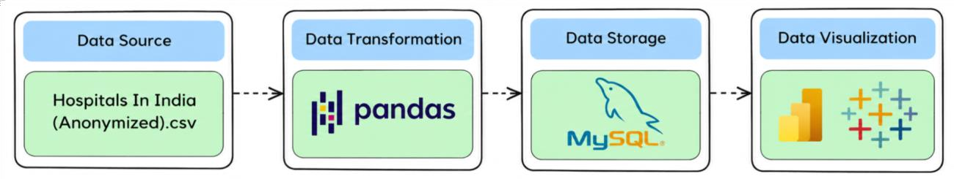

Program:
- Python – Data Cleaning & Transformation import pandas as pd df
= pd.read_csv("Hospitals In India (Anonymized).csv") hospitals = df.copy()

hospitals["City"] = hospitals["City"].fillna("Unknown") hospitals["State"]
= hospitals["State"].fillna("Unknown") hospitals["District"] = hospitals["District"].fillna("Unknown") numeric_columns = [
"Density", "Latitude", "Longitude", "Rating",
"Number of Reviews"
]
for column in numeric_columns: hospitals[column] =
hospitals[column].fillna(0) hospitals.drop_duplicates(inplace
=True) hospitals.columns = ( hospitals.columns
.str.lower()
.str.strip()

.str.replace(" ", "_")) print("Original Shape:", df.shape) print("Cleaned Shape:", hospitals.shape) print("\nDataset Preview:") print(hospitals.head()) print("\nDataset Information:") print(hospitals.info())

SQL SERVER CONNECTIVITY

INSTALL SQL SERVER MANAGEMENT STUDIO

Create database named “miniproject2”
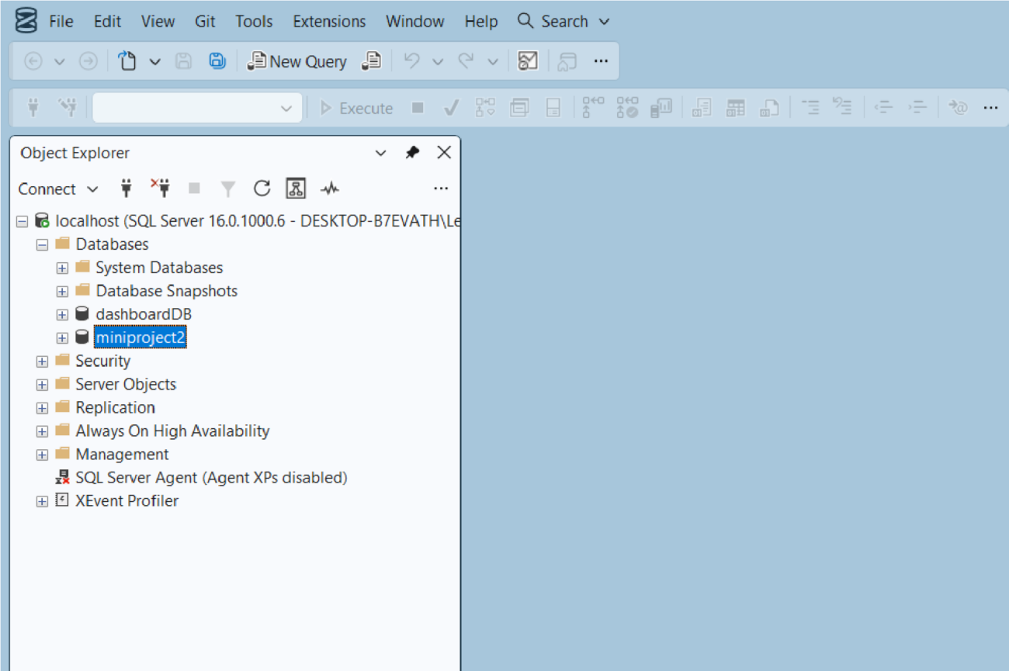

Import the csv file of the dataset

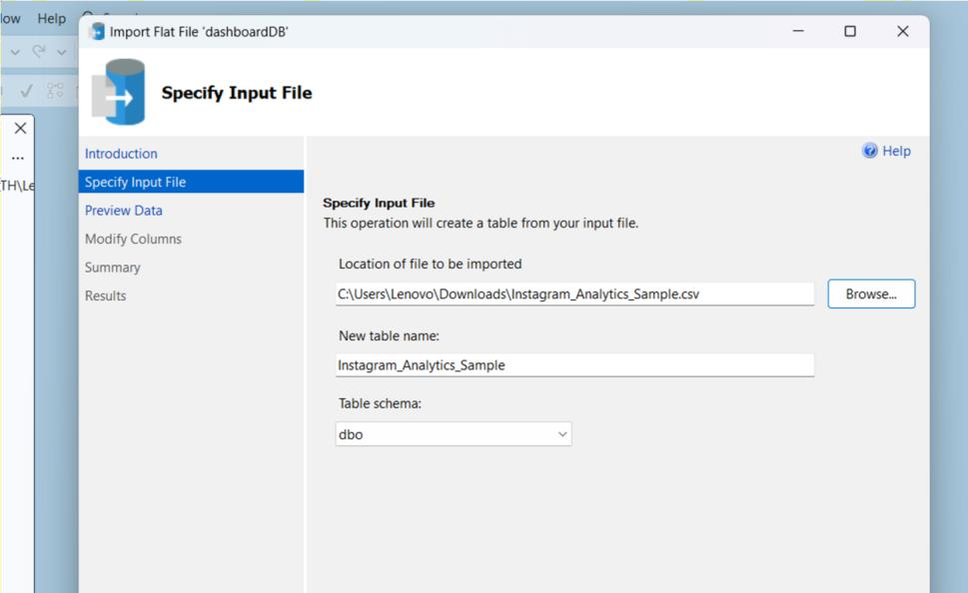

POWER BI

Now go to MICROSOFT POWER BI

Click SQL SERVER

Click OK and click transform data
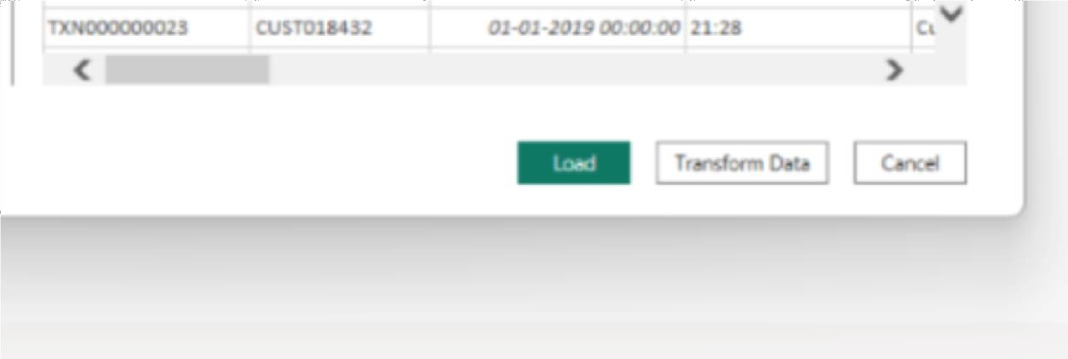

Create DAX measures TOTAL HOSPITALS :

AVERAGE RATING :

Power BI Final Executive Dashboard & Drill-Through

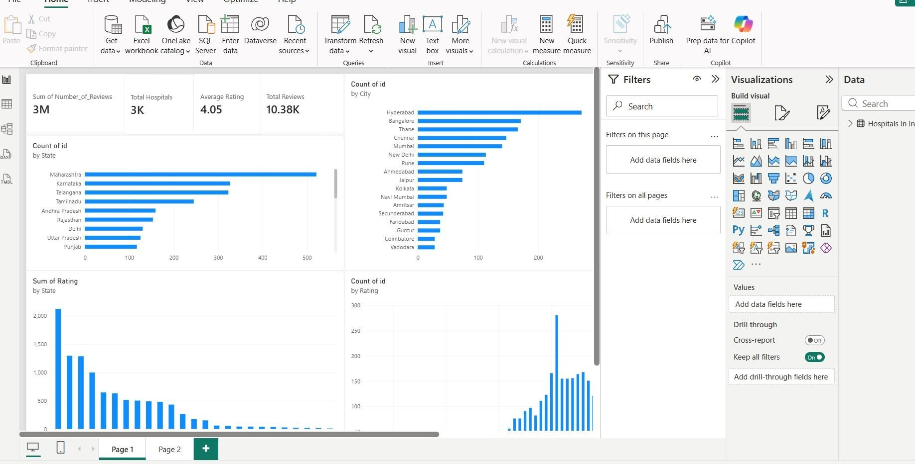

1. Executive Canvas:
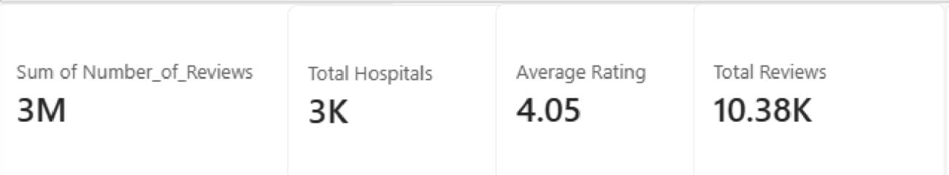
Place Card Visuals across the top:
Visualise number of hospitals in each state
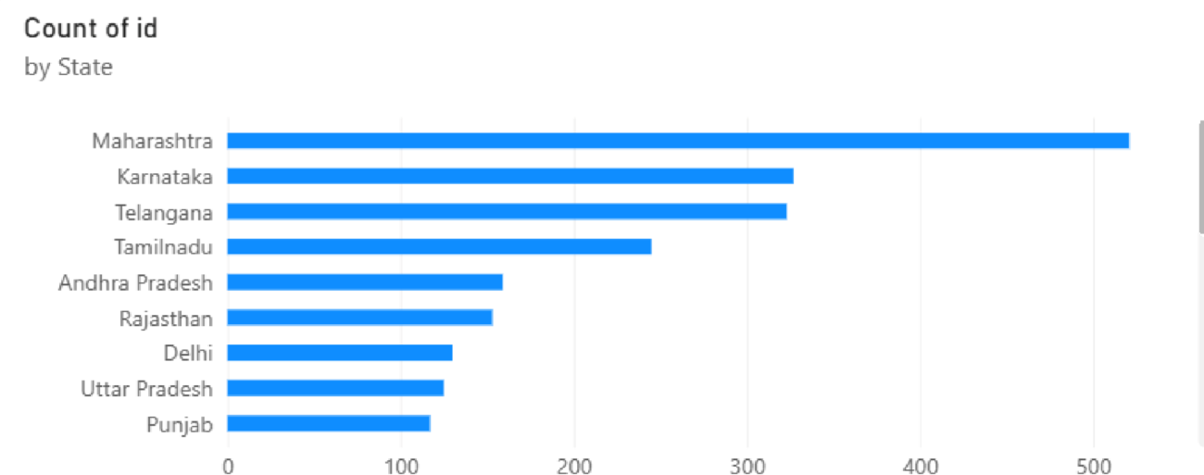

count number of hospitals by city

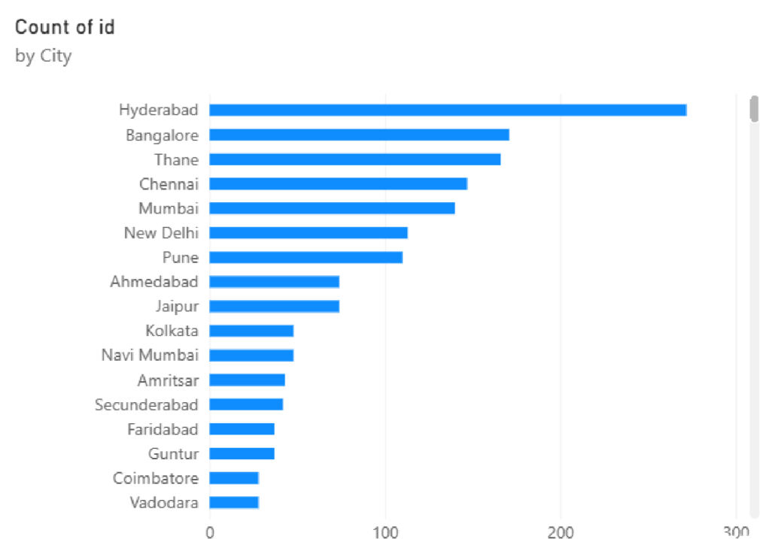
Count of id by rating
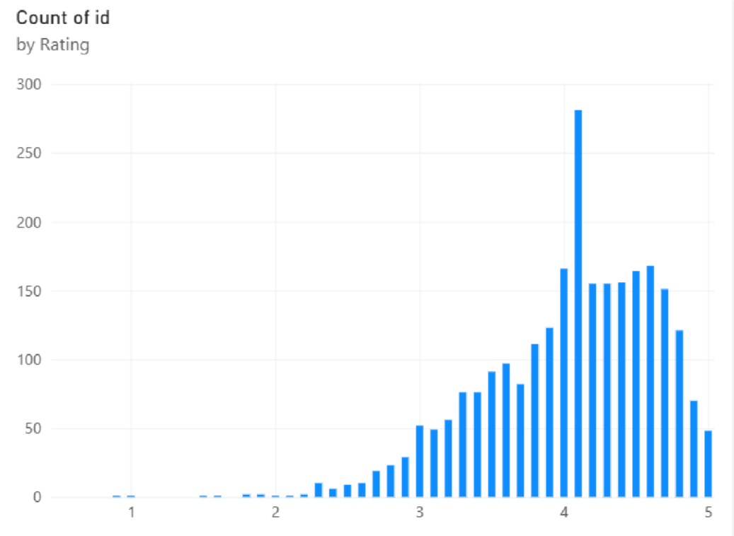
Total rating by states

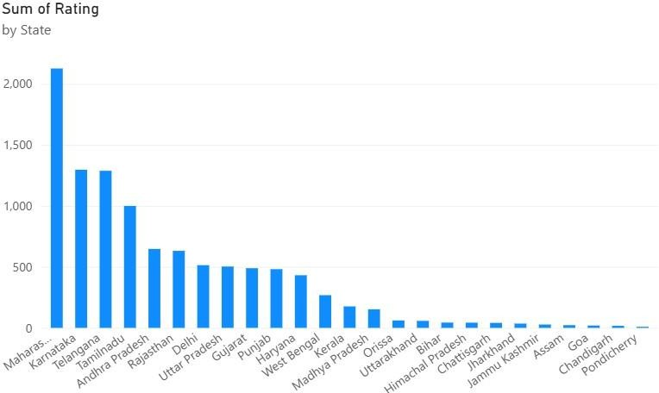

Create 2 slicers by state and city
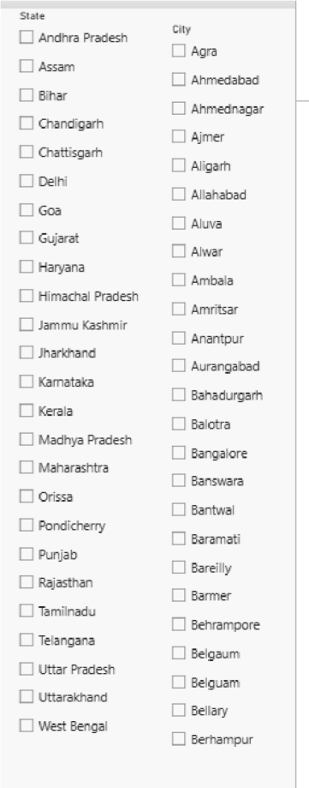

Implement drill through

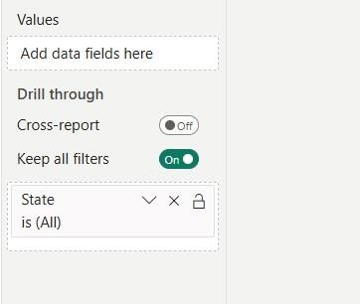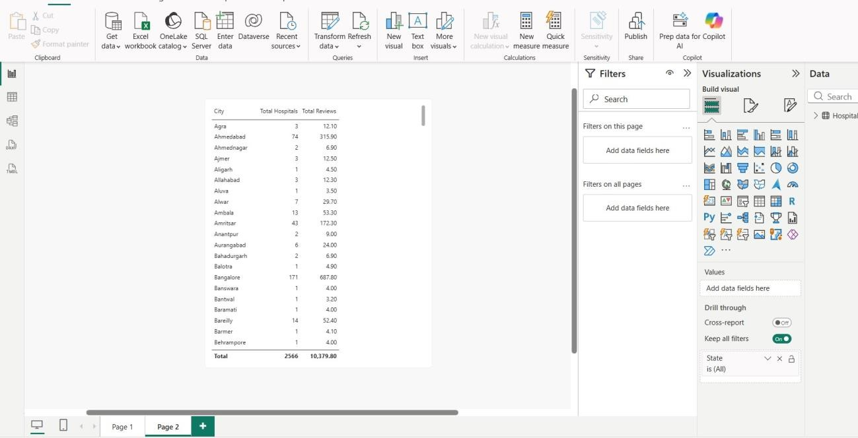

TABLEAU
Import the data from sql server

FINAL DASHBOARD :
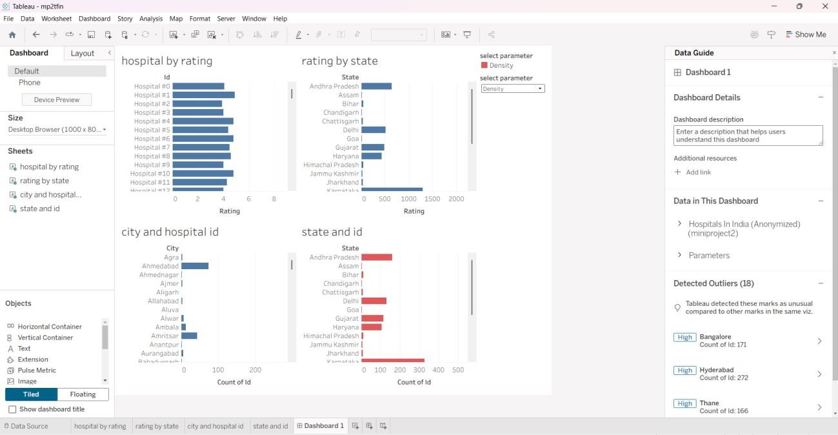
Build parameters

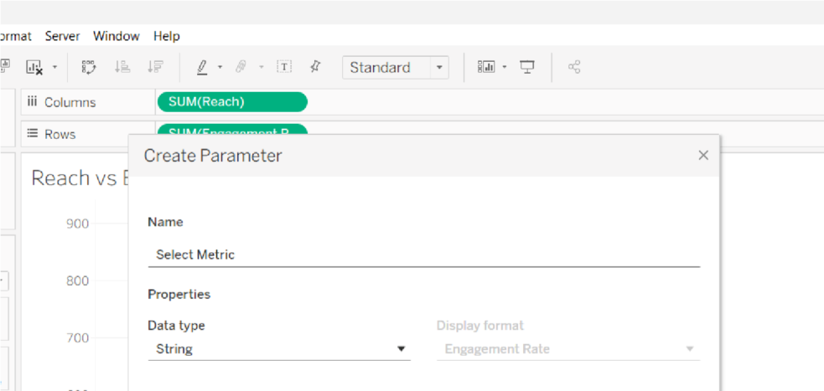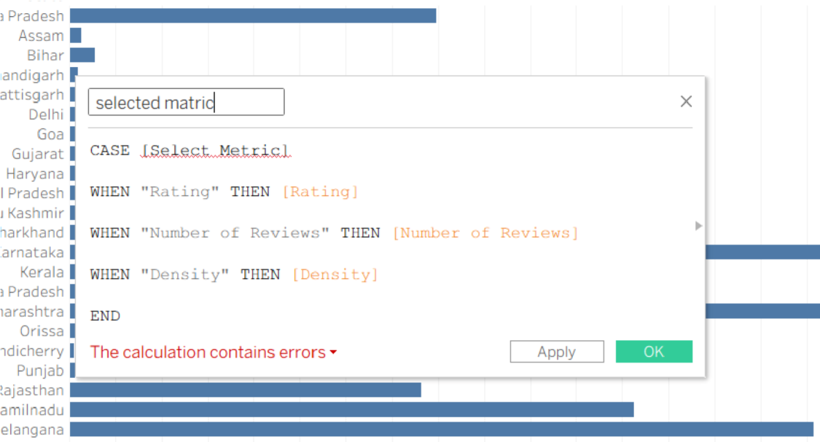

To visualise hospital by rating

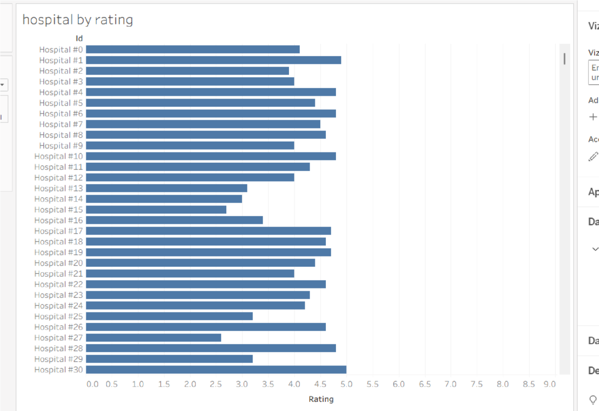

To visualize rating by state

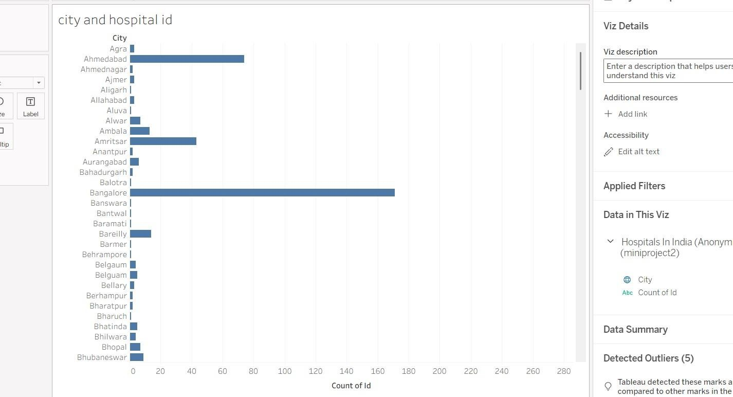
To visualize number of hospitals in each city

To visualise number of hospitals in each state
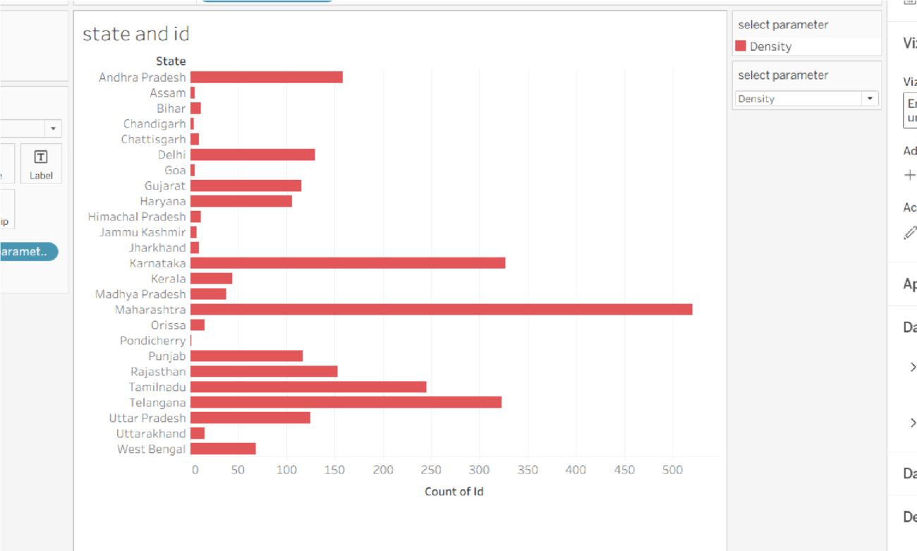

Observed Insights

- Hospital Ratings
Most hospitals have ratings between 3 and 5, indicating generally moderate to good ratings. Hospital #1 has the highest rating among the displayed hospitals, close to 5. The ratings are relatively consistent across the hospitals shown in the dashboard.

Rating by State
Karnataka has the highest rating-related value among the states displayed, followed by Andhra Pradesh. Delhi, Gujarat, and Haryana also show comparatively higher values than most other states. Several states such as Bihar, Assam, and Chandigarh have very low values in comparison.

Hospital Distribution by City
Ahmedabad has the highest hospital count among the cities displayed in the dashboard. Amritsar also has a noticeable number of hospitals compared with most other listed cities. Several cities such as Agra, Ajmer, Aligarh, and Allahabad have relatively fewer hospitals.

Hospital Distribution by State
Karnataka has the highest number of hospital IDs, followed by Andhra Pradesh and Delhi. Gujarat and Haryana also contribute a significant number of hospitals to the dataset. States such as Assam, Bihar, Chandigarh, and Chhattisgarh have comparatively fewer hospitals.

